**Ex. No : 3 B**

**Date : 13.02.2025**

**Develop application to demonstrate applications of JQUERY and AJAX**

**AIM:**

To Develop application to demonstrate applications of JQUERY and AJAX

**PROCEDURE:**

|  |  |  |
| --- | --- | --- |
| **S.NO** | **Jquery Functions** | **DESCRIPTION** |
| **1** | **$(document).ready()** | **Ensures the DOM is fully loaded before running jQuery.** |
| **2** | **Click()** | **Listens for button clicks (e.g., posting a question/answer).** |
| **3** | **Val()** | **Retrieves or sets input values.** |
| **4** | **Append()** | **Dynamically adds HTML elements (questions/answers).** |
| **5** | **Closest()** | **Finds the closest parent element for targeted removal.** |
| **6.** | **fadeOut()** | **Gradually hides elements (used for deleting questions).** |
| **7** | **slideToggle()** | **Expands/collapses answers smoothly.** |
| **8** | **$.ajax({...})** | **Sends an AJAX request to fetch data from the API.** |
| **9** | **$("#countryList").empty();** | **Clears previous results from the list before adding new data** |

**SOURCE CODE :**

<!DOCTYPE html>

<html lang="en">

<head>

<meta charset="UTF-8">

<meta name="viewport" content="width=device-width, initial-scale=1.0">

<title>Countries and Capitals</title>

<script src="https://code.jquery.com/jquery-3.6.0.min.js"></script>

<style>

body {

font-family: Arial, sans-serif;

}

.container {

width: 50%;

margin: auto;

text-align: center;

}

ul {

list-style: none;

padding: 0;

}

li {

padding: 8px;

background: #f4f4f4;

margin: 5px 0;

border-radius: 5px;

}

</style>

</head>

<body>

<div class="container">

<h2>Countries and Their Capitals</h2>

<button id="fetchData">Fetch Countries</button>

<ul id="countryList"></ul>

</div>

<script>

$(document).ready(function() {

$("#fetchData").click(function() {

$.ajax({

url: "https://restcountries.com/v3.1/all",

method: "GET",

success: function(data) {

$("#countryList").empty();

data.forEach(country => {

let countryName = country.name.common;

let capital = country.capital ? country.capital[0] : "No Capital";

$("#countryList").append(`<li><strong>${countryName}</strong>: ${capital}</li>`);

});

},

error: function() {

alert("Error fetching data.");

}

});

});

});

</script>

</body>

</html>

**OUTPUT 1 :**

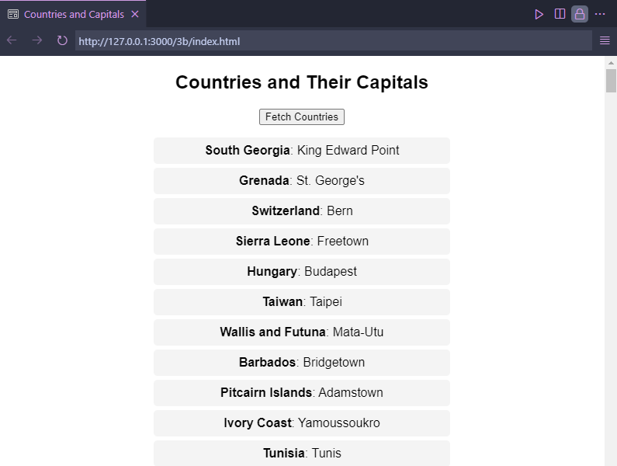

**RESULT :**

The program has been successfully executed and the output is verified.